bOverview Page:
Replace:
We are precision.
Shell moulded iron castings · 0.5 kg–500 kg · Kolhapur, India · ISO 9001:2015
With:
Shell moulded & no-bake iron castings.
0.5 kg – 500 kg · Machined to drawing · ISO 9001:2015 · Kolhapur, India

Replace:
From pour to finished part.
Engineered to spec
Built to come apart.
Cored, cavitied and shell moulded to assemble clean — every casting leaves dimensionally certified and ready to drop straight into your build.
And go back better.
Every dimension checked against your drawing. Every heat spectrometer-verified. Nothing leaves the floor without sign-off.
With:
Pattern to mould.
Shell and no-bake moulding, cored to your cavity geometry — built to hold tolerance through the pour.
Mould to pour.
500 kg induction melt, poured at a controlled temperature. Chemistry locked before the ladle moves.
Pour to certified part.
Every heat spectrometer is checked. Every dimension was verified against the drawing. UT and BHN where the spec calls for it. Nothing ships without sign-off.
(This keeps your three-beat scroll rhythm, but each beat now names an actual process step instead of a pun — it also naturally builds toward the spec block that follows, so the page reads as one continuous process rather than three separate taglines.)

Replace:
The part inside the machine.
Inside Caterpillar excavator arms. Inside Halliburton pump heads. Inside Schwing concrete delivery systems.
With:
Where they end up.
Supplied into Caterpillar excavator arms. Halliburton pump heads. Schwing concrete-delivery systems.

About Us Page:

Replace:
Trusted by companies that don't compromise on quality.
With:
Supplying OEMs on four continents.

Replace:
The foundry is the team.
With:
The people behind the pour.

Replace:
Operators are trained through process discipline, shop-floor supervision and inspection feedback — accountability from raw material to shipment.
With:
Operators are trained on the floor, under direct supervision, with every batch checked against inspection records — accountability from raw material to shipment.

Replace: Vision and Mission to this

Vision — To be a globally recognised, trusted partner delivering innovative, sustainable, and high-quality casting solutions.
Mission — To produce superior castings through advanced technologies, long-term partnerships, and a culture of excellence, safety, and continuous improvement.

Replace:
The foundry is lit.
With:
The furnace is lit.

Remove Wikov and SAS sanwa and vanaz replace them with John Deere and Ingersoll Rand and TEL(Turbo Energy Limited)

Replace:
Italy · United Kingdom · Japan · USA — shipped from Kolhapur

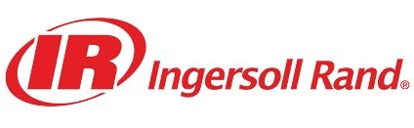

Europe· United Kingdom · USA

Foundry Page:

Replace:
HMC. VMC. CNC Lathe. On-site. Your casting doesn't leave our facility until it's machined, dimensionally verified, and ready for your assembly line. One partner. One responsibility. Zero gaps.
With:
HMC. VMC. CNC Lathe. On-site. Your casting doesn't leave our facility until it's machined, dimensionally verified, and ready for your assembly line — cast, machined, and inspected under one roof.

Replace:
Trusted by companies that don't compromise on quality.
With:
On the floor at these OEMs.

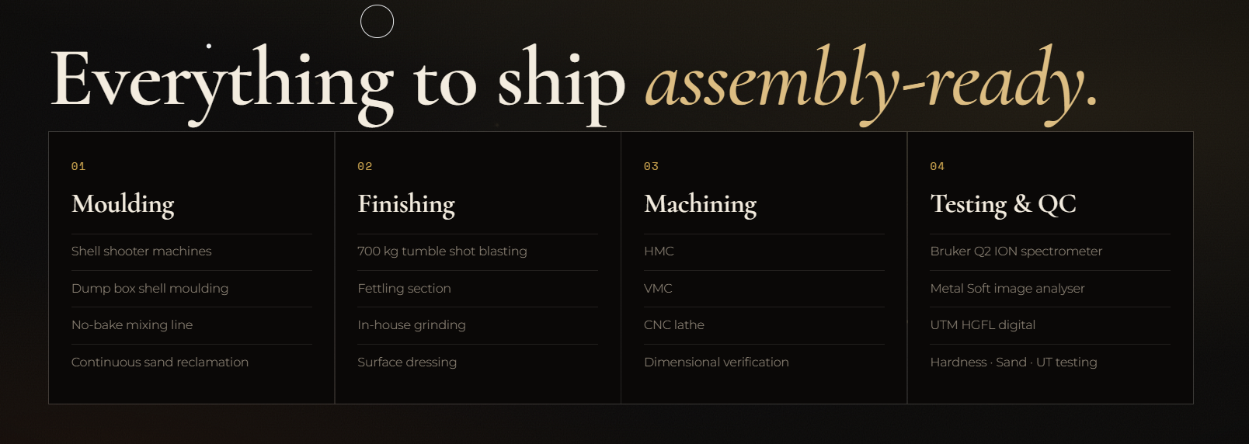

Need images here to show machines I will give you photos

Products page:
Automobile:
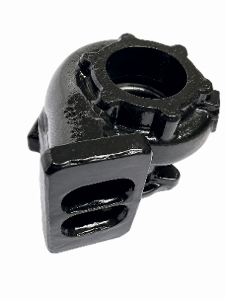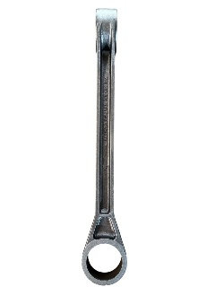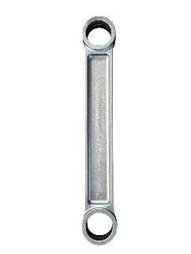

Turbo Charger shell moulded casting Torque rod Shell Moulded Casting

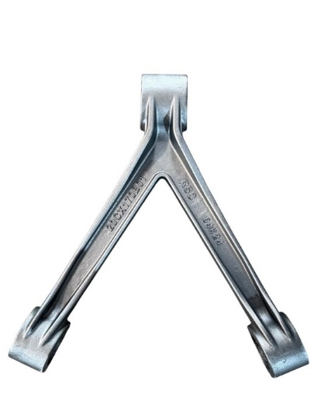
V frame Shell Moulded casting

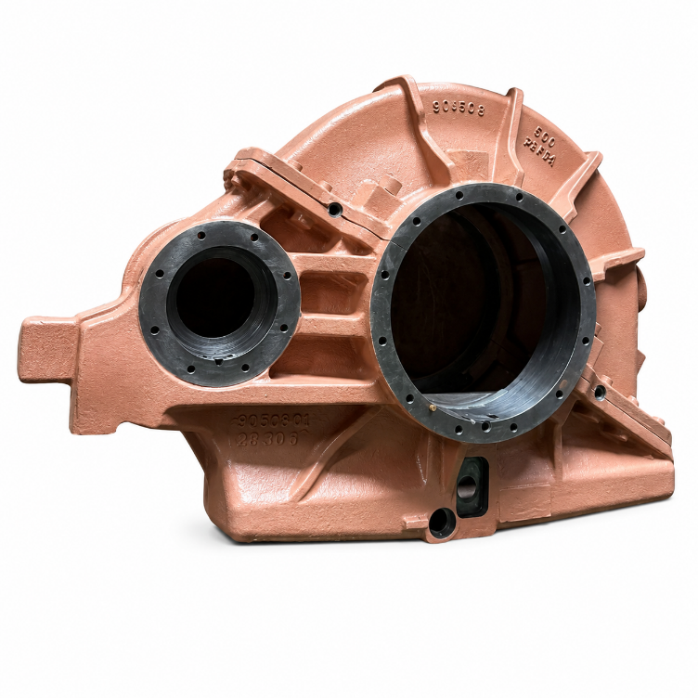
No Bake Casting Gear box
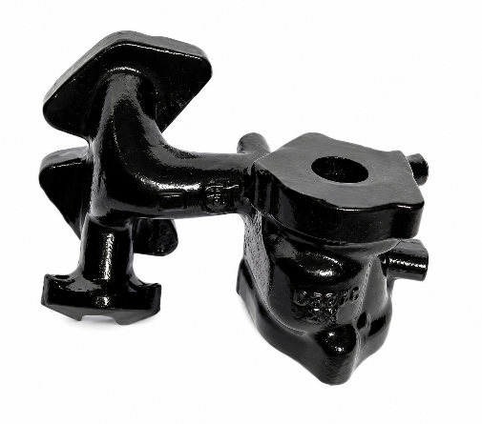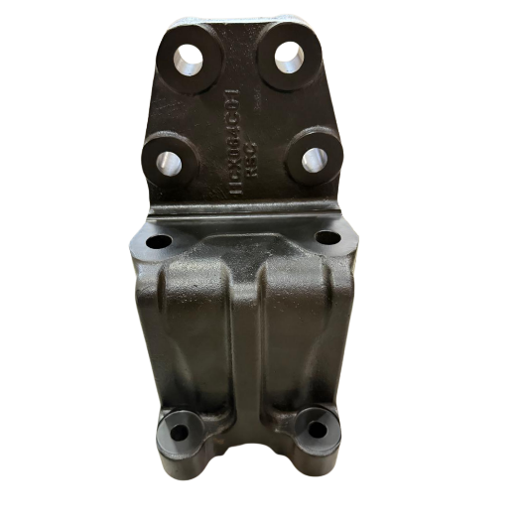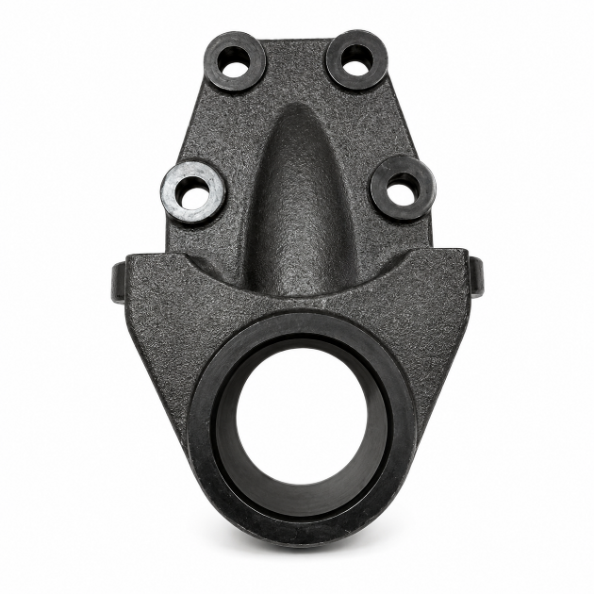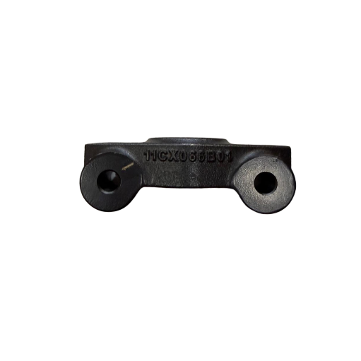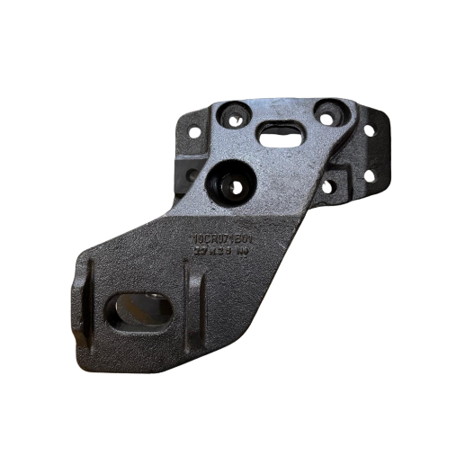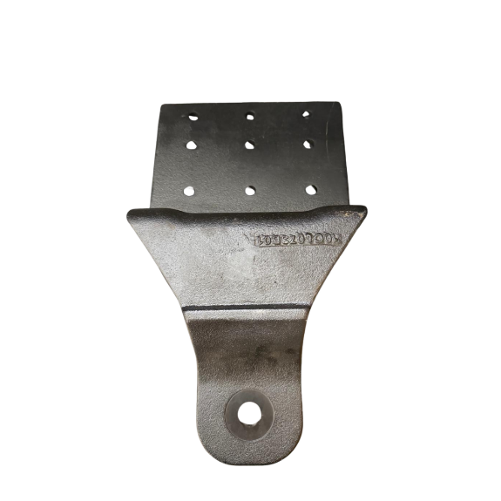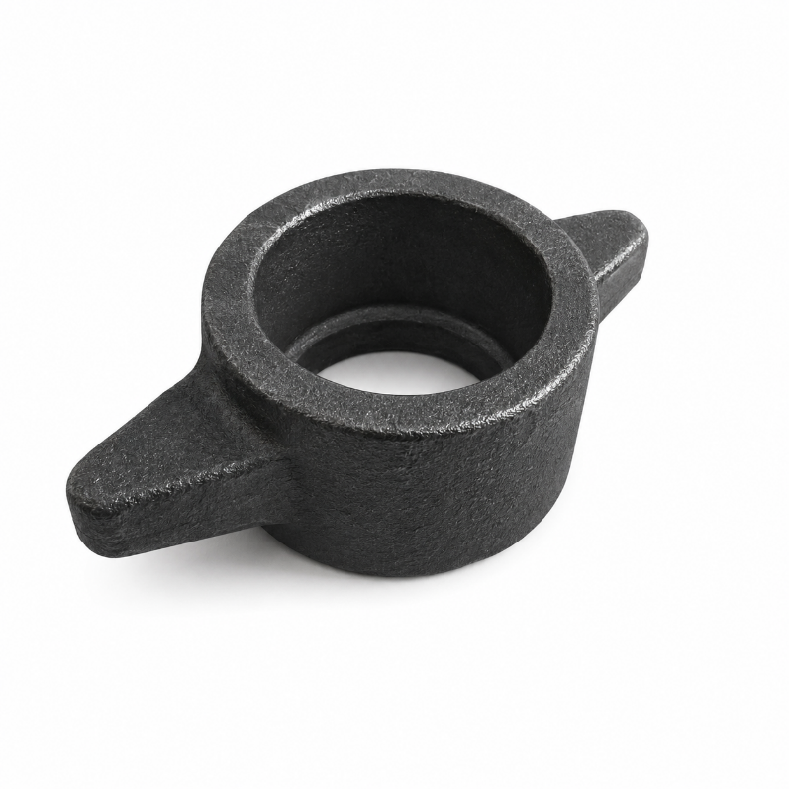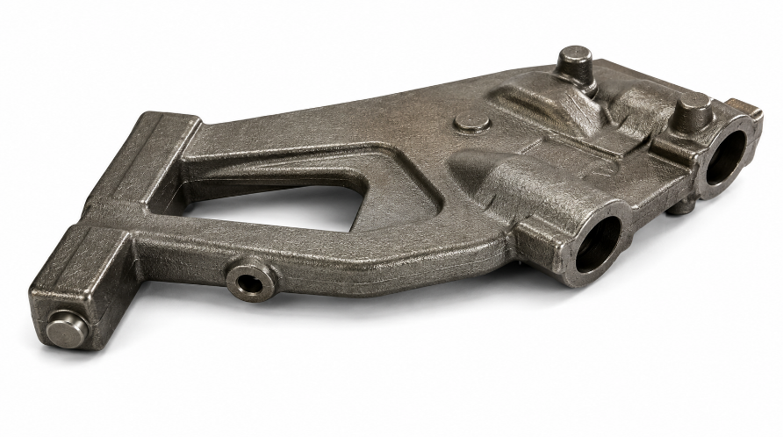

Hydraulic:
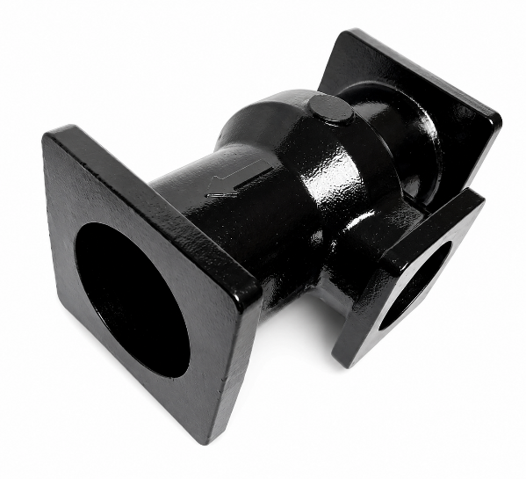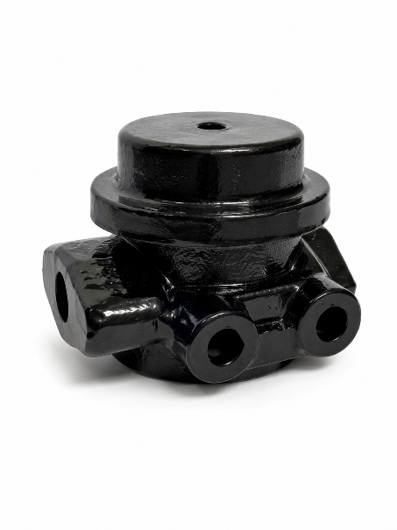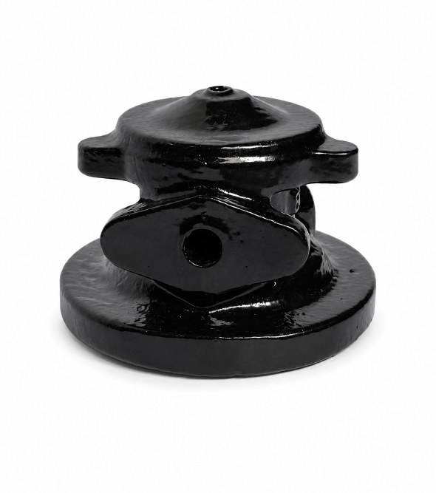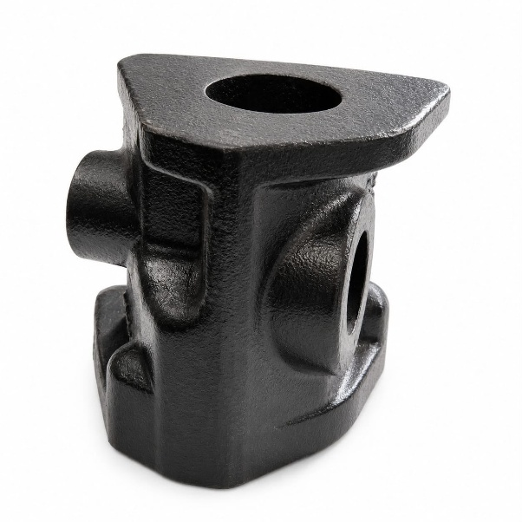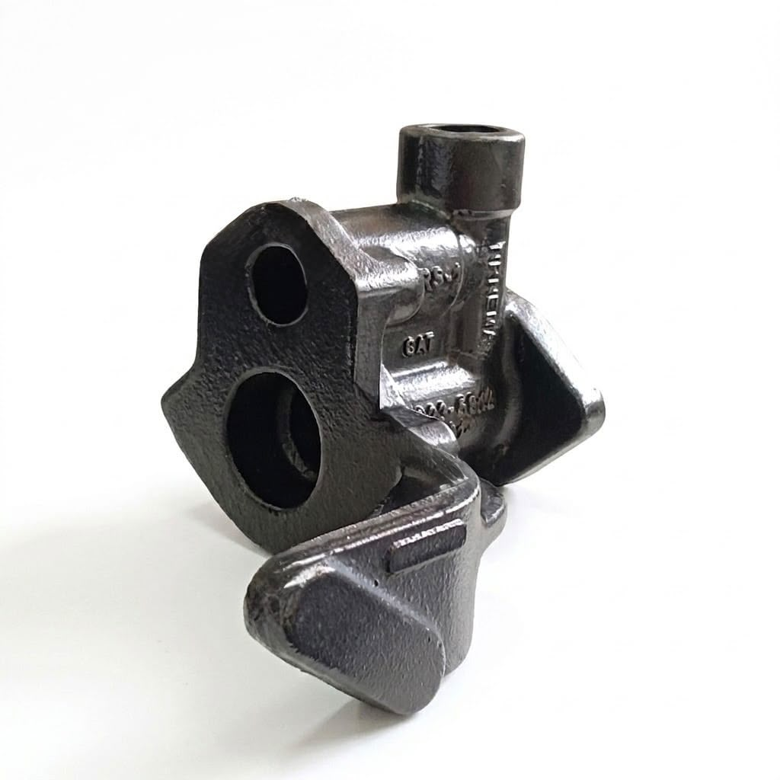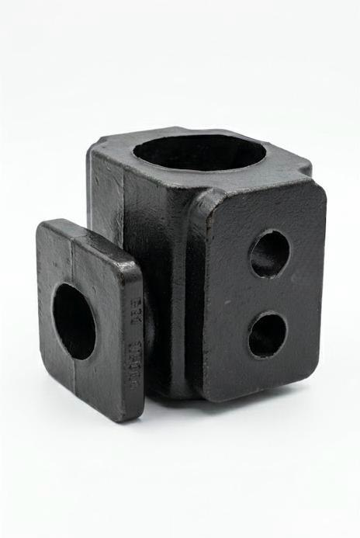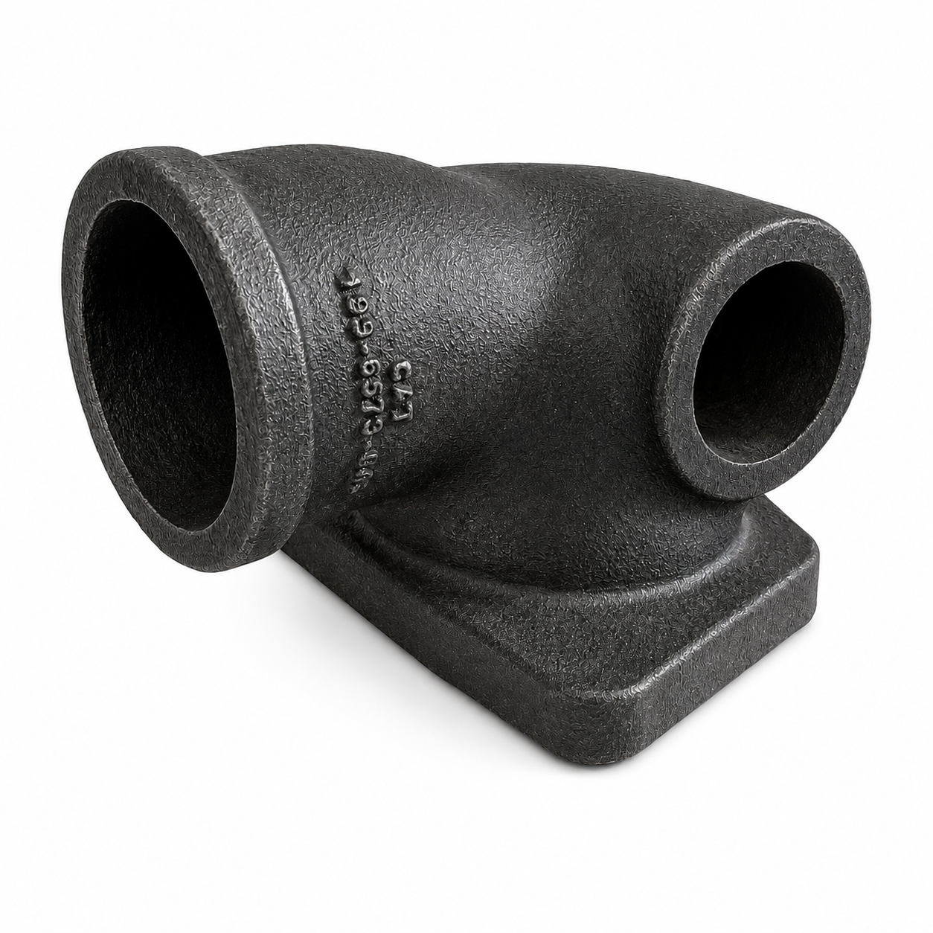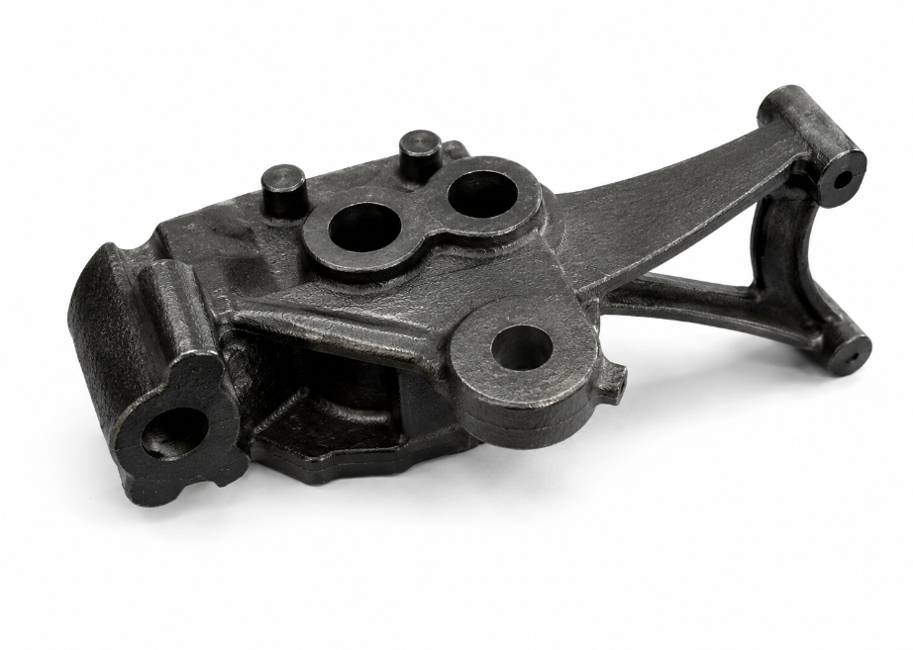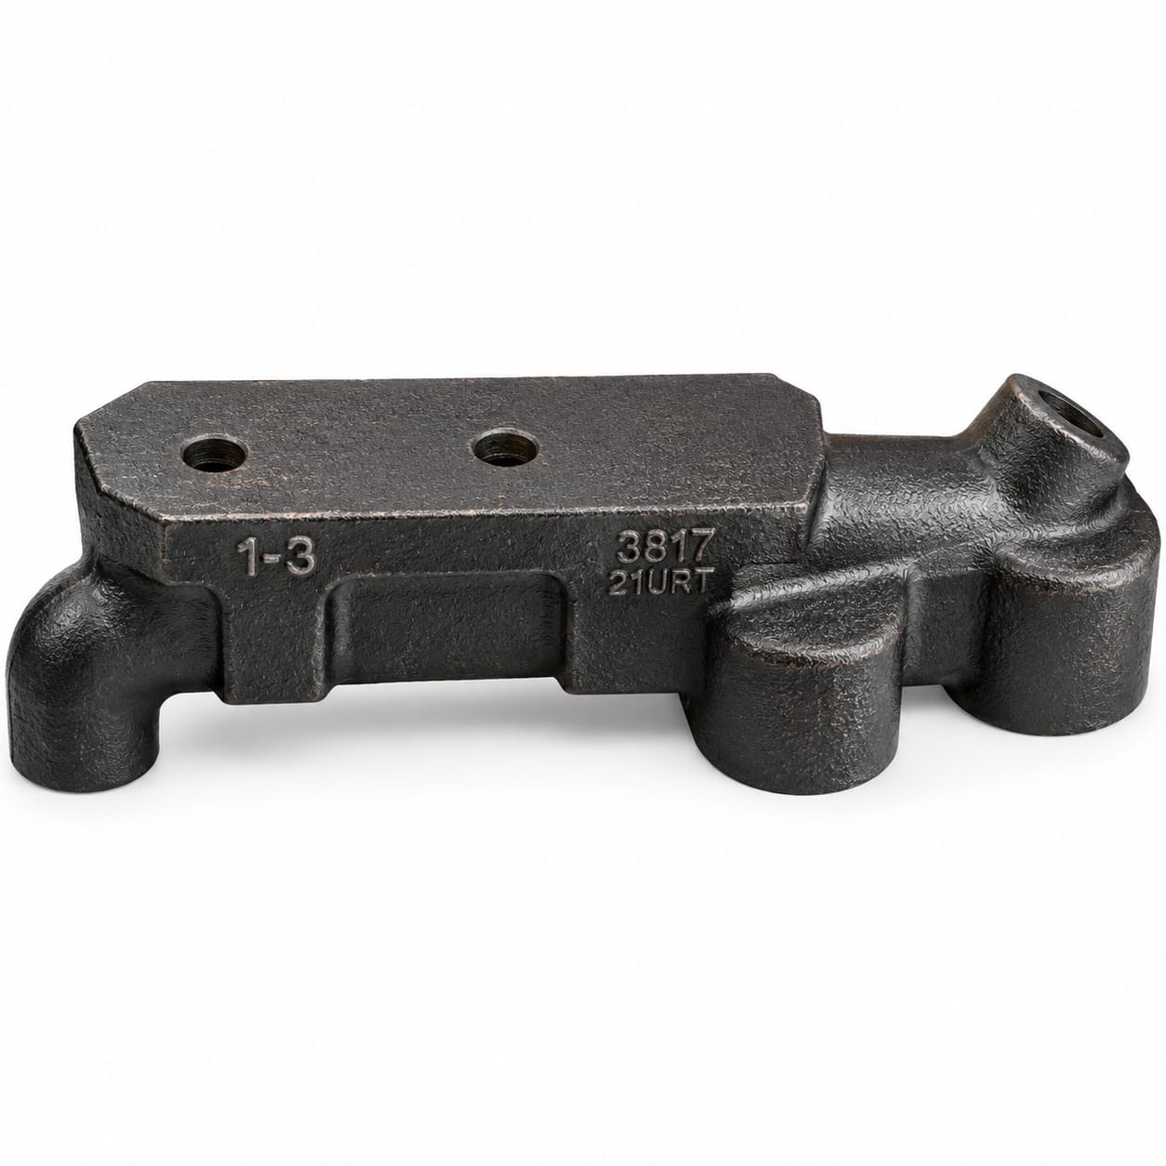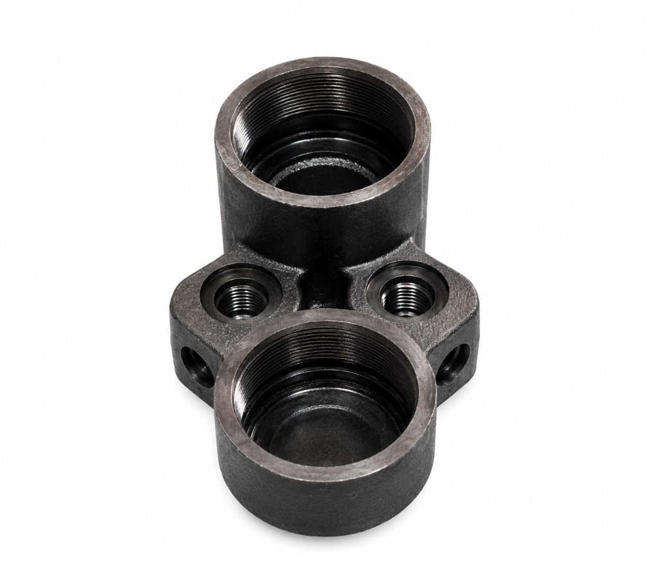

Oil And Gas
